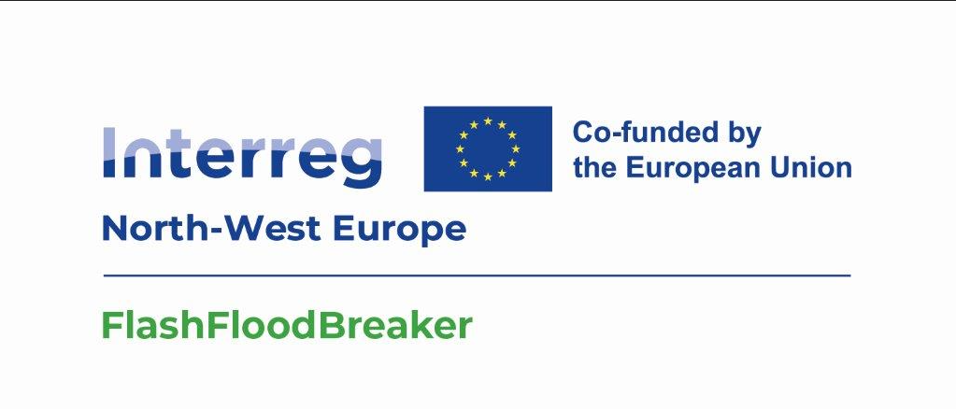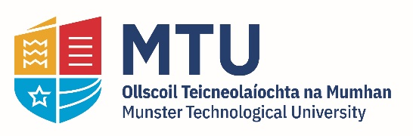
FlashFloodBreaker - PhD Scholarship
Hydrological Modelling

Sustainable Infrastructure Research & Innovation Group (SIRIG)
School of Building & Civil Engineering
MTU Cork Campus
March, 2024

PhD Scholarship
The MTU Sustainable Infrastructure Research & Innovation Group (SIRIG), School of Building & Civil Engineering is pleased to offer a PhD scholarship for research in the area of flash flood and hydrologic modelling. The scholarship is set within the Flash Flood Breaker Project which is a collaborative large-scale project (2024-2027) (https://sirig.mtu.ie/our-project/flash-flood-project-breaker-2024-2027/).

The project is funded through the Interreg NWE Programme with a large multi-partner project team.

Project Background and Detail
The project aims to make North-West Europe (NWE) more resilient to increasing extreme flash flood events. The project focuses on assessing flood vulnerability, developing a flood-resilient framework, reducing flood hazards and creating a decision-making platform to tackle extreme flash floods in real-time.

The project will test innovative integrated modelling, AI-based forecasting and real-time data collection by drones applicable throughout NWE. Furthermore, it aims to demonstrate responsive flood communities for emergency response at the local and transnational levels and integrate validated solutions into strategy/action plans to manage floods in the future.

NWE has been strongly affected by extreme flash flood events in recent years. July 2021 is one devastating example of the impact an extreme flash flood can have, where over 200 fatalities and widespread damages and infrastructures disruption were recorded in DE, BE, NL, LU, FR, IE and CH. A flash flood is a rapid rise of water in low-lying areas that occurs within only 3-6 hours of a heavy rainfall. Due to climate change (more frequent extreme weather events) and increasing settlement of residential and commercial buildings, the flash flood risk is increasing in NWE.

NWE-territories at a higher risk are urban, polder and steep valley areas. In those areas, flash floods can originate from both fluvial and pluvial sources. In case of fluvial sources, flash floods arise from tributaries. Adapting to extreme flash flood with conventional protection methods is restricted due to land-use constraints. Thus, there is a need to develop new approaches to effectively manage extreme pluvial and fluvial flash flood-related risks in NWE to avoid/minimise human and economic losses and damages.

To tackle flash flood disasters, the project will develop and test new holistic approaches by integrating hydrological modelling with AI and machine learning tool, collection of data in real time using drone survey. Pluvial and fluvial models will be combined to carry out stress tests of the current flood protection systems and assess its vulnerability. Further, the impacts of the cascading effects will be integrated to current inundation models to predict material and economic impacts of flash floods in the different risk-affected areas.

To support emergency response, innovative data-driven approaches to real-time forecast inundation extent and impacts or using drones will be piloted for the first time in the distinct areas. On this basis, early warning systems can be upgraded to alert crisis management units and citizens of upcoming flash floods and help them make collective or individual decisions.

PhD Scholarship Details
The successful candidate will receive a stipend of €21,000 per annum for the duration of the PhD (up to December 2027) and an annual contribution of €6,000 towards tuition fees. Attendance at project meetings and conferences will be facilitated.

An outline of the work which the successful candidate will undertake as part of his/her/their PhD research includes:

- Conduct research in the hydrological aspect and flash flood generation
mechanisms across multiple river basins in Ireland and North-West Europe
- Study and follow the technical literature including academic papers, journals, and textbooks to keep abreast with the state-of-the-art on the topic.
- Actively participate in field activities such as drone survey, stakeholder engagement, training activities and submit progress reports in fulfilment of the project requirements.
- Present the research outcomes at meetings, project workshops, and to external audiences to disseminate and publicise research findings in line with the FFB project.
- Record, analyse and write up results of research work and contribute to the production of research reports and publications.
- Carry out routine administrative duties as requested, e.g. arranging research programme group meetings, contributing to research programme website, contributing to the organisation of FFB workshops and events.
- Plan own day-to-day activity within the framework of the agreed research and training programme, manage own time and meet agreed deadlines.
- Make internal and external contacts to develop knowledge and understanding and form relationships for future collaboration.

This research position, which is currently available, offers candidates an opportunity to work within a large EU research consortium and as part of a multidisciplinary research environment within MTU. The PhD candidate will have opportunity for national and international travel to conferences and for project collaboration. The PhD candidate will also work closely with colleagues in MTU in the Sustainable Infrastructure Research & Innovation Group.

Applicants should hold (or about to obtain) a Bachelor degree (minimum final grade 2.1 or equivalent) or a Master Degree in Civil Engineering, Water Resources Engineering, Environmental Engineering or a similar cognate discipline. Fluency in English and excellent written and oral presentation skills are required. Additional desirable criteria for the candidate include:

- Sufficient breadth or depth of specialist knowledge in hydrology, statistics, data analysis, computer programming, Geographical Information System.
- Ability to logically conceptualise and summarise research findings.
- Ability to work proactively and independently, as well as in a team, under pressure, respect deadlines, and produce quality work.
- Ability to communicate complex information clearly, and demonstrable intellectual ability.
- Have or about to obtain a Masters (ME/MTech/MSc) in Civil Engineering, Water Resources Engineering, Environmental Engineering, or in a related field.
- Relevant knowledge of quantitative analysis, experience in field work activities, and/or other research experience.
- Strong analytical and problem solving skills.
- Excellent interpersonal skills and an enthusiasm for working in a research team.

Written applications, in English, should include a concise C.V., a one-page letter of motivation describing why you are interested in this position, an English language test certificate, if applicable and contact details for three references. Along with the application, please include a copy of relevant qualifications such as official university transcripts. Please email applications to Dr. Joe Harrington (joe.harrington@mtu.ie) or Dr. Bidroha Basu (Bidroha.basu@mtu.ie) by 16.00CET /17.00GMT on Wednesday 27th March. Shortlisted candidates will be called for an interview in April, 2024.

